CS 557 - Winter Quarter 2024 - Project #2 Report

# TITLE: Noisy Elliptical Dots

*Submitted by: Manogna Challoju*

*Email:* [*challojm@oregonstate.edu*](mailto:challojm@oregonstate.edu)

The goal of this project is to implement noise-modified elliptical blending using a GLIB file for glman or the GLSL API and I used glman. The primary parameters to be varied include uNoiseAmp, uNoiseFreq, and uUseXYZforNoise. This report outlines the implementation details and considerations for achieving the desired effect.

Implementation:

The GLSL code provided utilizes a noise texture to modify the blending of an elliptical shape with its surroundings.

Key parameters include:

* uNoiseAmp: Controls the amplitude of the noise.
* uNoiseFreq: Sets the frequency of the noise.
* uUseXYZforNoise: A boolean determining whether to use (s,t,0.) or (x,y,z) for noise computation.

The noise is obtained from a 3D texture (Noise3) using the specified coordinates. If uUseXYZforNoise is true, the texture is sampled using 3D model coordinates (vMCposition). Otherwise, it uses 2D texture coordinates (vST,0.). The resulting noise value is then scaled and used to modify ds and dt values.

The implementation includes per-fragment lighting, similar to Project #1, to enhance the visual quality of the scene.

The noise-modified ds and dt values are used to determine the color based on an elliptical equation. The final color is determined by blending between two specified colors (c0 and c1) using the modified elliptical equation.

The implemented noise-modified elliptical blending provides a visually interesting effect, showcasing the flexibility of GLSL and glman in creating dynamic and interactive graphics. By varying parameters such as uNoiseAmp, uNoiseFreq, and uUseXYZforNoise, users can experiment with different configurations to achieve diverse visual outcomes.

**Screenshots and Video:**

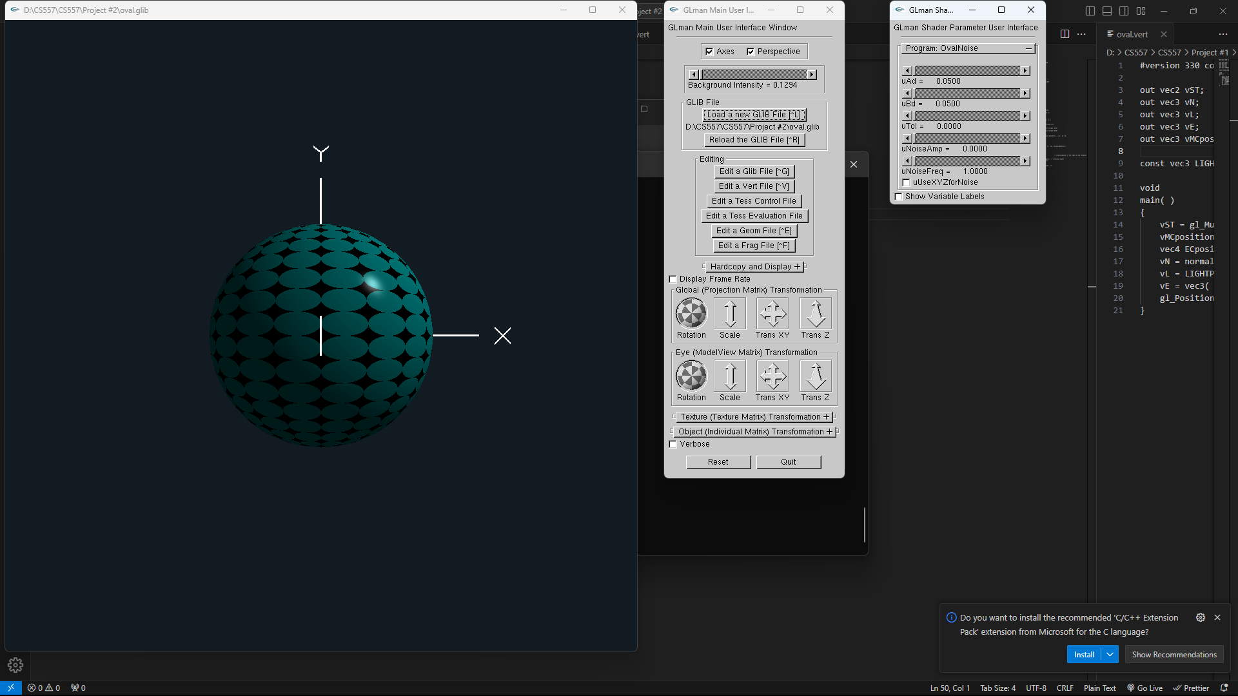

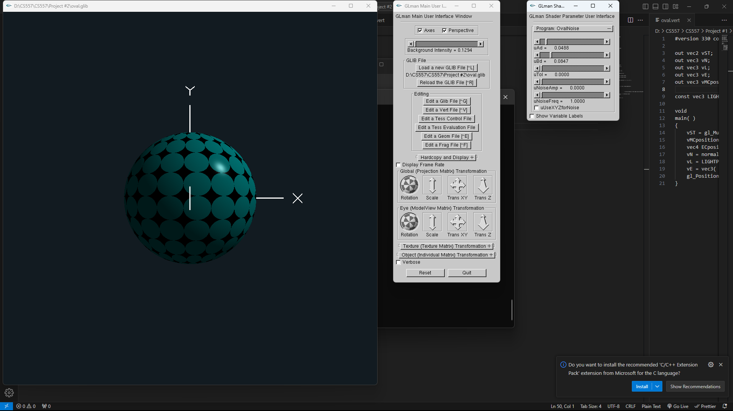

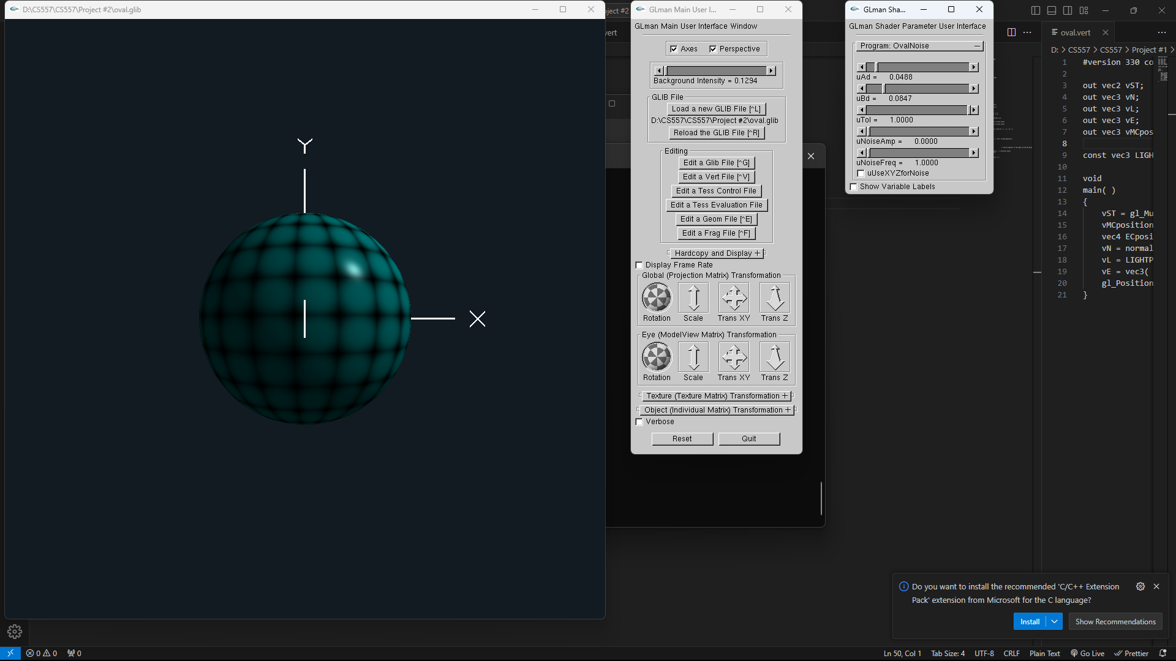

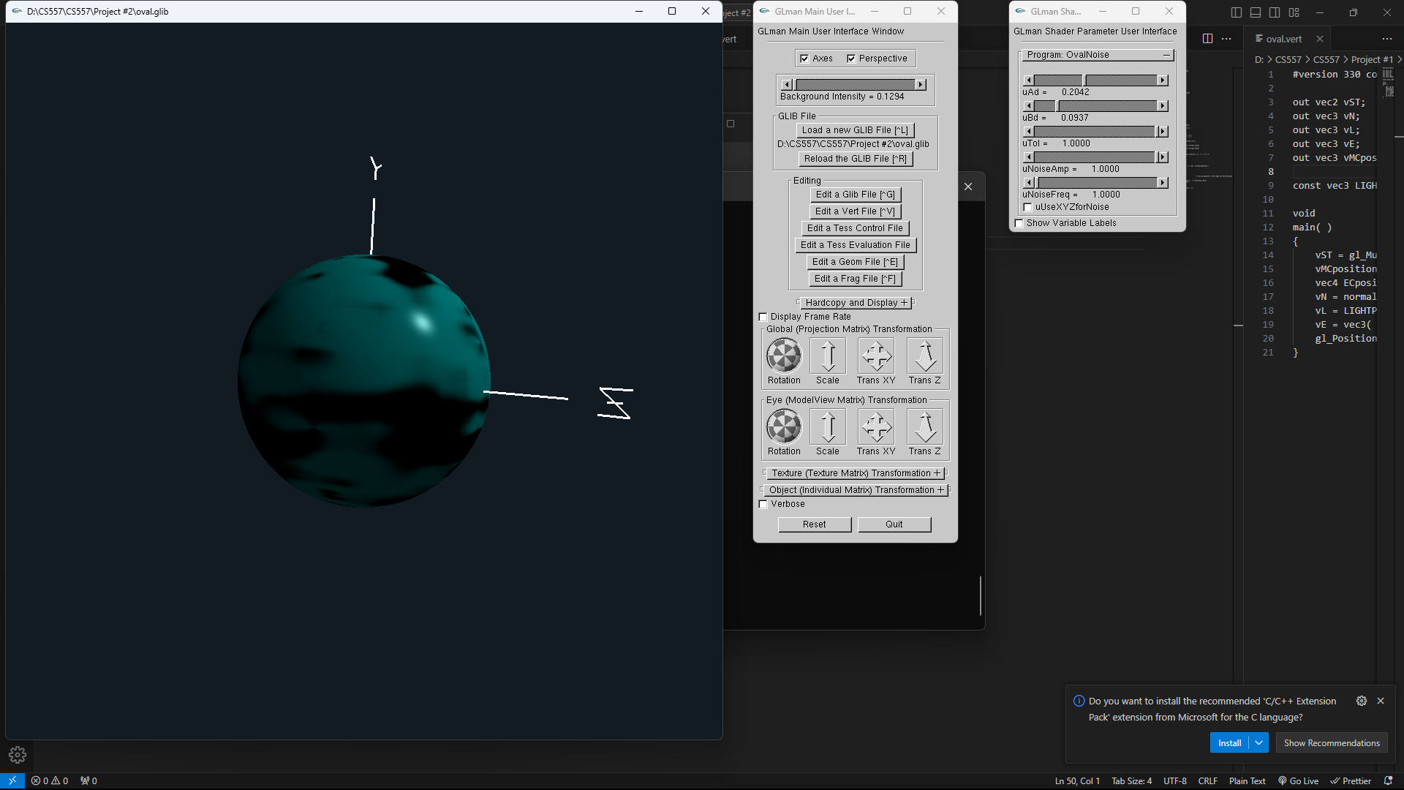

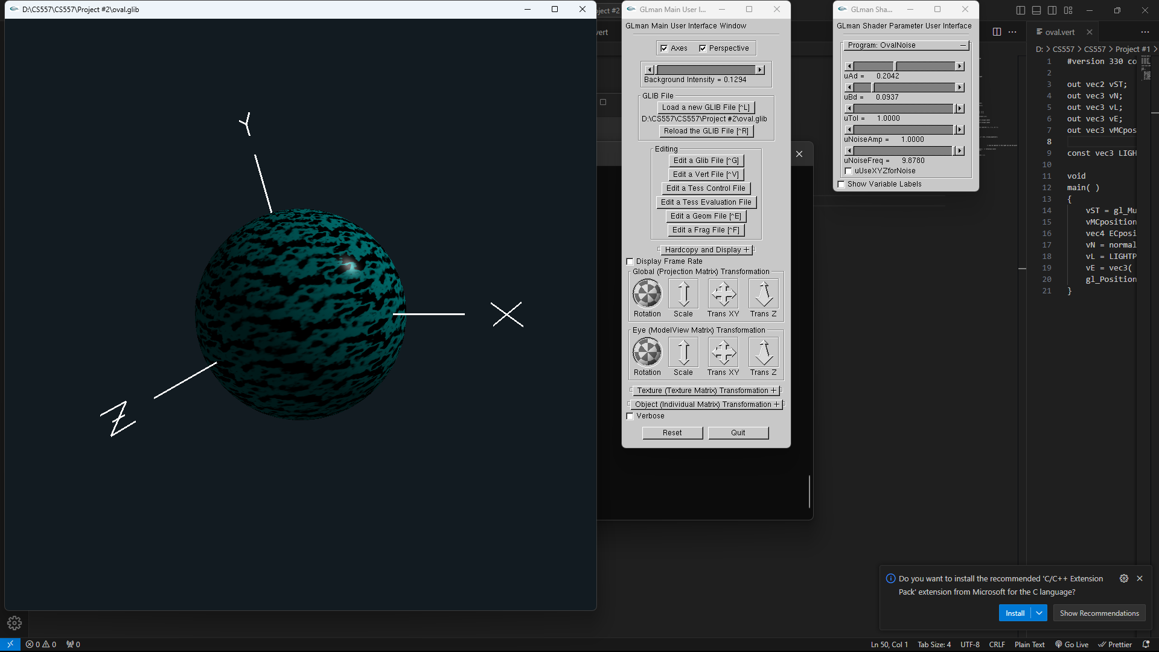

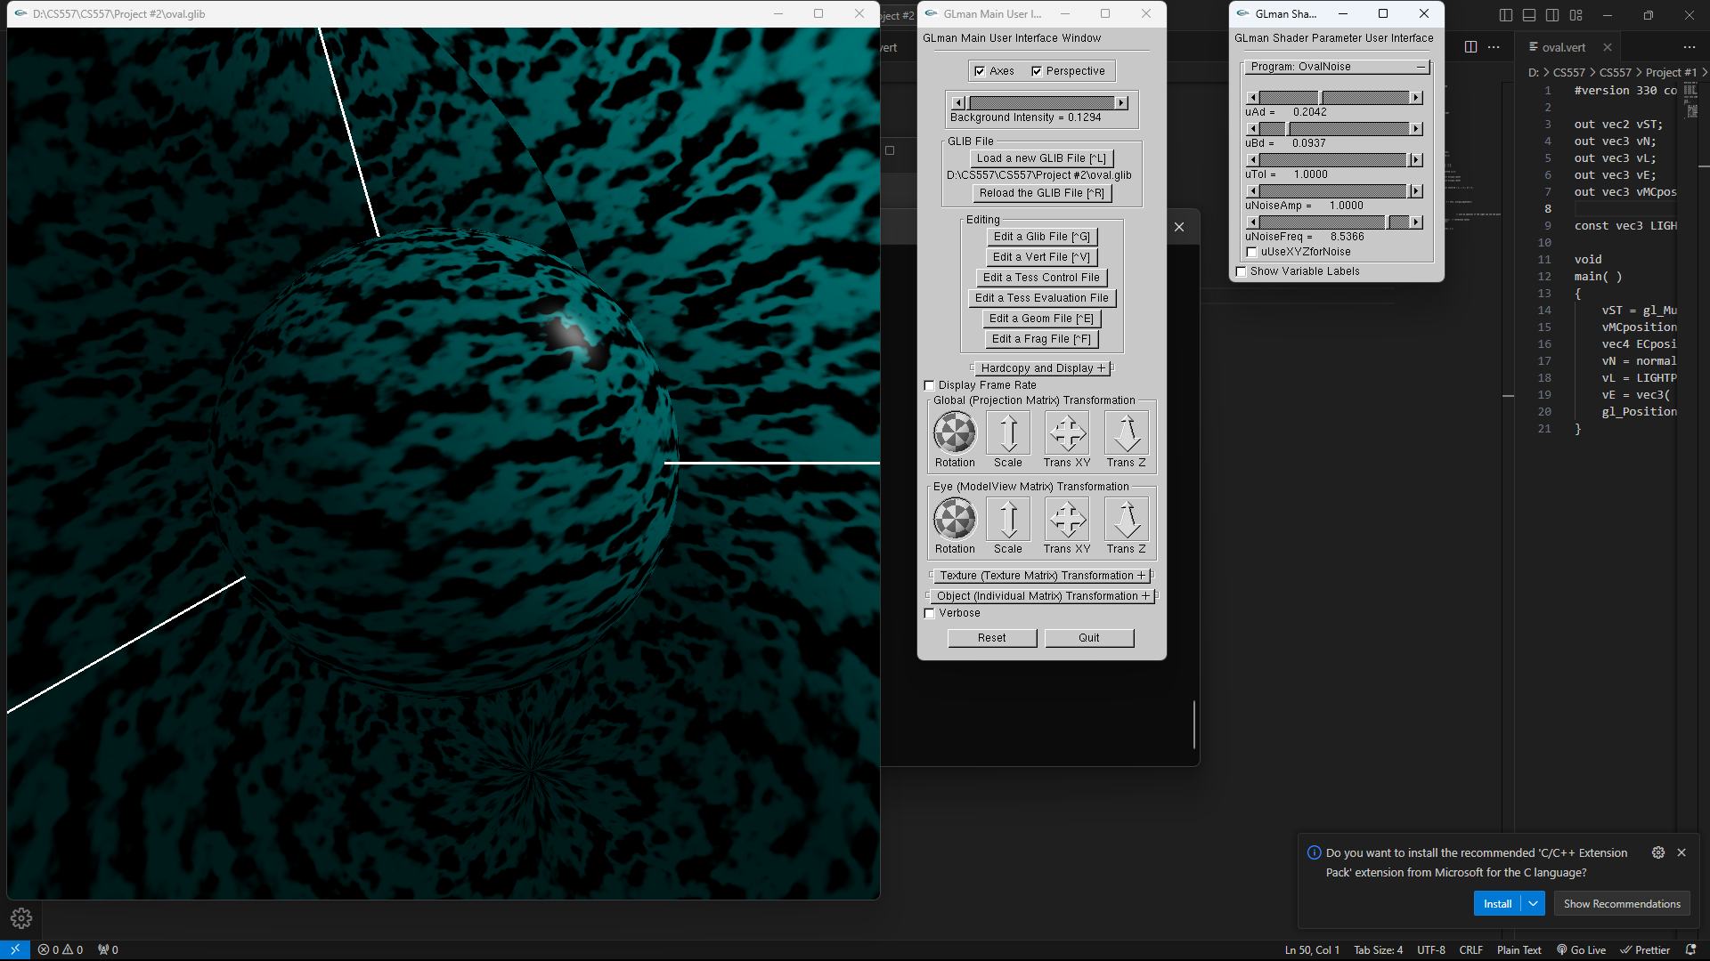

**Kaltura Link** – [Project#2 - Manogna Challoju - OSU MediaSpace (oregonstate.edu)](https://media.oregonstate.edu/media/1_vl768gd3)